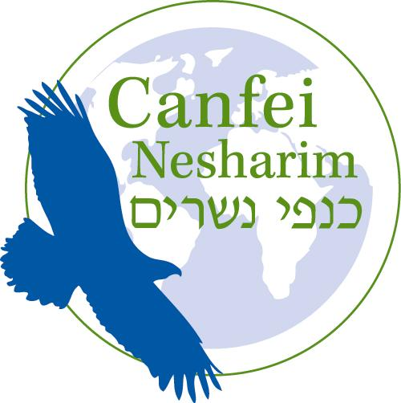



Passing the Test of Wealth: A Challenge for Our Time
By Rabbi Yonatan Neril

The Talmud teaches that money is what stands a person on their feet. The holy, conscious use of the physical world is a key means to serving G-d. Wealth can provide us with food, clothing, shelter and other needs. For one who is wealthy, proper use of wealth can be a force for positive change in the world.

The Jewish tradition does not call for living as ascetics or in poverty. However, wealth can also be a corrupting influence. A wide range of rabbinic teachings provide insights on the place of wealth in Jewish thinking. One particular example is the story of Korach, which expresses the harm that can come from material wealth.

Korach, a leading member of the Israelite tribe of Levi, assembled a group of 250 prominent Israelites to challenge the leadership of Moses and Aaron in the desert. The Torah narrates the response G-d designated for Korach and his followers: “The earth beneath them opened its mouth and swallowed them and their houses, and all the men who were with Korach and all the property.”

What was behind the demise of Korach and his followers? Based on the Torah mentioning that the earth swallowed up all the property of Korach's assembly, the Talmud teaches that Korach was extremely wealthy.
Rabbi Ephraim Luntchitz writes that the wealth of Korach's fellow rebels overtook them, generating power-seeking based on greed. Reflecting upon this, he cautions that “money [can] rise up against a person and rule over him and cause him to go against his own intelligence and the awareness of [G-d]...This acquisition [money] leads its owner to great danger, and is what killed Korach, since he trusted in his wealth and then fell.”

According to this teaching, the wealth of Korach and his followers inflated their sense of entitlement, leading them to think that they, not Moses and Aaron, should lead the Jewish people. Korach and his followers allowed their wealth to distort their perspective, ultimately leading them to challenge Moses’ leadership. As a result, Korach's assembly (and their property) was consumed by the earth.

Today our society is also being misled by our wealth, with serious harm as a potential consequence. We have been living comfortably upon the abundant resources of the world, and feeling secure with our possessions and advanced technology, without fully recognizing the effects of our actions.

A report of the World Business Council for Sustainable Development, comprised of executives from major international corporations, identifies ‘a culture of ‘consumerism’ among higher income groups, which account for the greatest per capita share of global consumption. The report continues that “global consumption is putting unsustainable and increasing stress on the Earth’s ecosystems.” A report by National Geographic also notes that “consumers in wealthy countries have a proportionately greater impact on the environment than others.”

How much does present-day consumption draw on the resources of the earth? The “Living Planet Report 2012,” co-produced by the Zoological Society of London, researched how many acres of biologically productive space the average person uses per year, in terms of their food, water, energy, and other consumption. The unit of measure is a global hectare (gha), a unit used by scientists to quantify the biocapacity of the earth. According to the report,

“In 2008, the Earth’s total biocapacity was 12 billion gha, or 1.8 gha per person, while humanity’s Ecological Footprint was 18.2 billion gha, or 2.7 gha per person. This represents an ecological overshoot of 50 per cent. This means it would take one and a half years for the Earth to regenerate the renewable resources that people used in 2007….”

Humanity’s environmental impact or ‘footprint’ on the planet is a ‘macro’ problem observed by thousands of scientists, in the form of air and water pollution, species extinction, and now climate change. But at its core it is a ‘micro’ problem centered on the human being, his or her use of money, and the desires that drive our consumption. As members of affluent Western society, how will we use our wealth for good?

One way for an individual to avoid being controlled by wealth is to give it to people or causes that need it more than we do. Rebbe Nachman of Breslov teaches that donating to people in need is an effective way to break a mindset of just wanting to increase one's own material comfort level. Instead of constantly seeking a nicer house, a fancier car, a more luxurious vacation, we can ask ourselves, do we need everything that we have? Do others have everything that they need? What can we give to others? And are we using our resources for holy purposes, or being taken over by them like Korach?

In our contemporary consumer culture, over-consumption represents a particular challenge. We are members of a society more wealthy than any in history, and we are being tested by our use of wealth in ways never before seen in the history of Jewish life. Jewish tradition teaches us to beware the dangers that wealth can pose. May we use our resources for holy purposes and to help others, and meet the tests that wealth presents.

This material was produced as part of the Jewcology project. Jewcology.com is a new web portal for the global Jewish environmental community. Thanks to the ROI community for their generous support, which made the Jewcology project possible.

Rabbi Yonatan Neril founded and directs Jewish Eco Seminars, which engages and educates the Jewish community with Jewish environmental wisdom. He has worked with Canfei Nesharim for the past six years in developing educational resources relating to Judaism and the environment.

The author thanks Evonne Marzouk for her helpful editorial comments.
Babylonian Talmud, Tractate Sanhedrin 110a
Numbers 16:3
Deuteronomy 16:32
Babylonian Talmud, Tractate Sanhedrin 110a
Author of Kli Yakar, Prague 1550-1619, commentary to Deuteronomy 11:6
“Sustainable Consumption Facts and Trends, From a Business Perspective,” World Business Council for Sustainable Development, p. 9, online at http://www.mapeo-rse.info/sites/default/files/Sustainable_consumption_facts_and_trends_from.pdf
“Greenscan 2009 Survey—Consumer Choice and the Environment—A Worldwide Tracking Survey,” online at http://environment.nationalgeographic.com/environment/greendex/2009-survey/
A study in the journal Nature states that the global ecosystem “is approaching a planetary-scale critical transition as a result of human influence.” See “Approaching a state shift in Earth’s biosphere,” Barnosky et al, June 7, 2012, online at http://www.nature.com/nature/journal/v486/n7401/full/nature11018.html
Likutey Moharan 13:1, see also Likutey Halachot, Hilchot Tefillah 4:14 by Rabbi Natan Sternhartz
For more on this theme, see the materials on ‘Holy Use: Relating to Resources Sustainably,” at http://www.canfeinesharim.org/coreteaching7/

